**Assignment – 1**

**Power BI Desktop and sharing the final screenshot of the report view page**

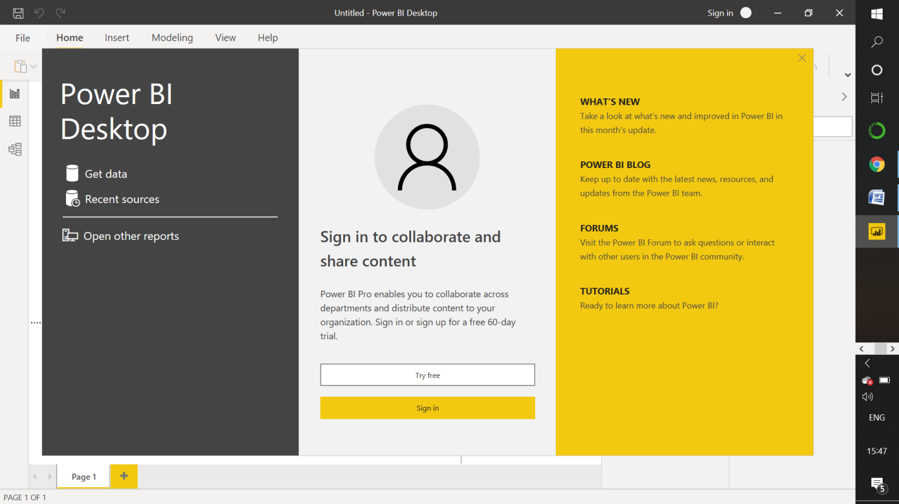

**• Preparing a document and with the following screenshots**

**Report View**

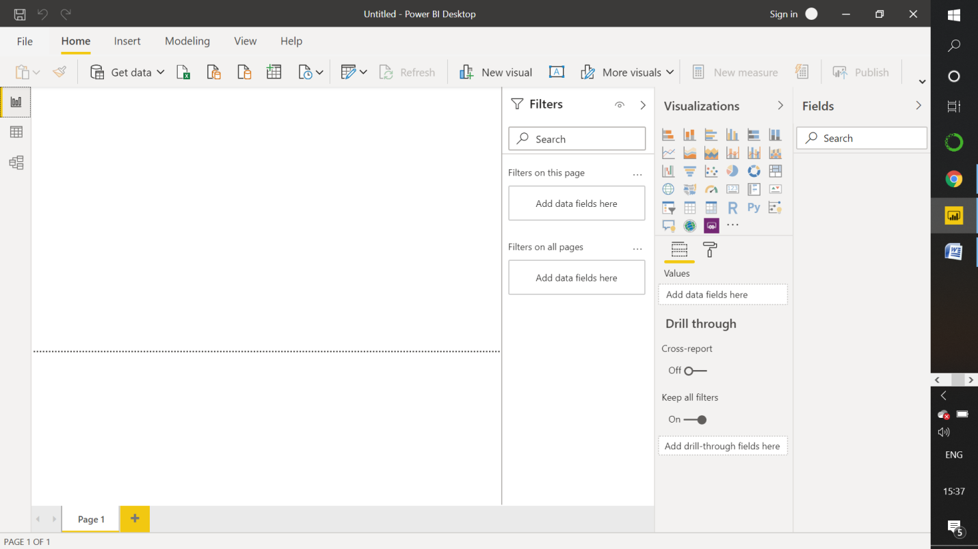

**− Data View** 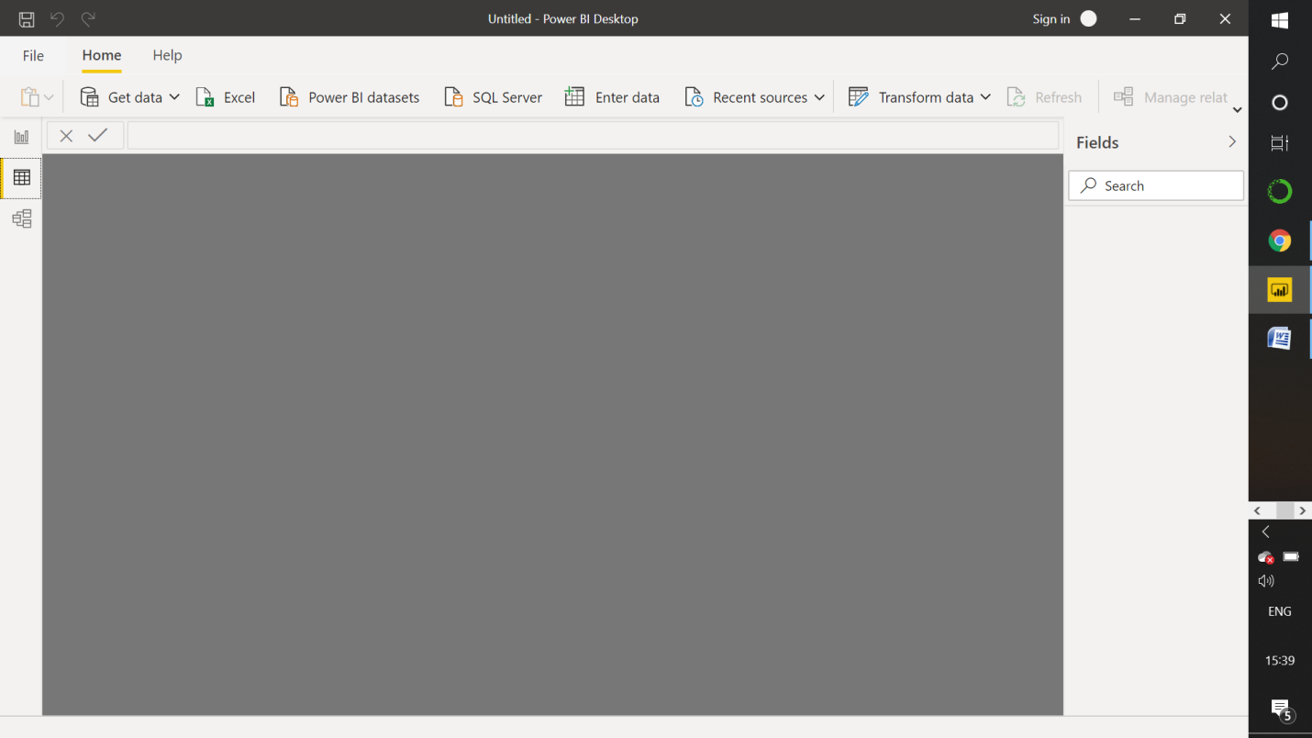

**Model View: –**

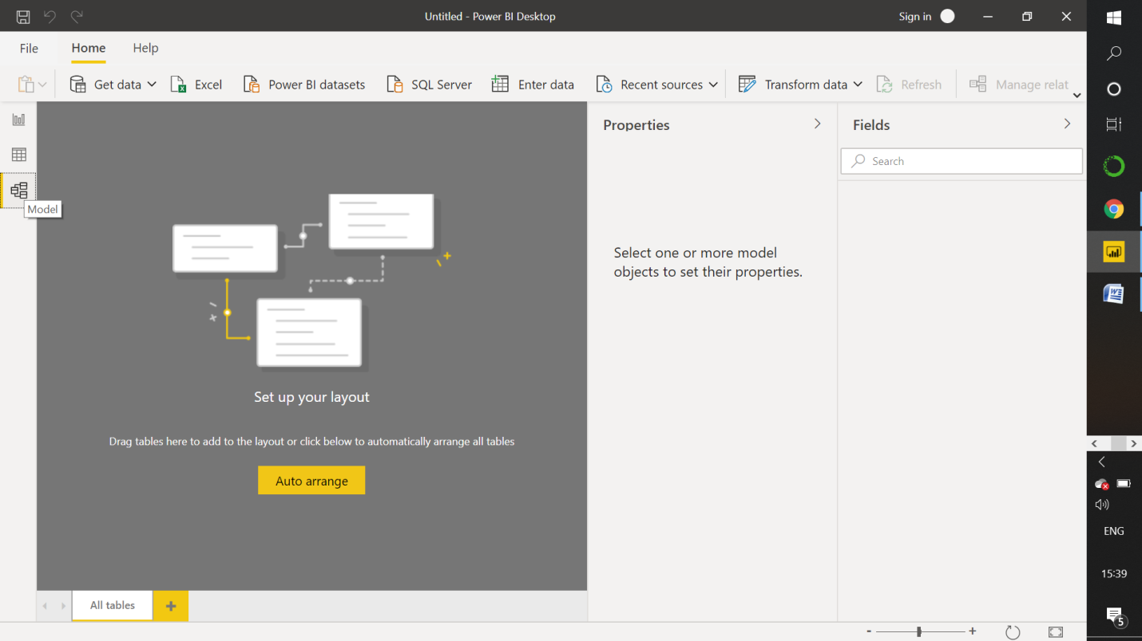

**Power Query Editor**

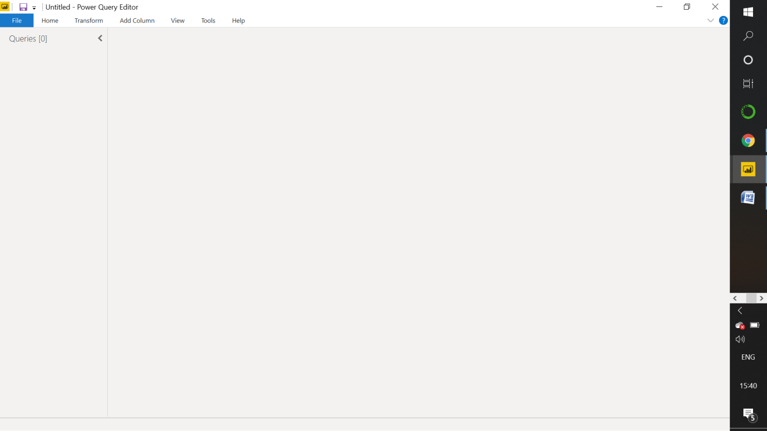

**− Advance Editor**

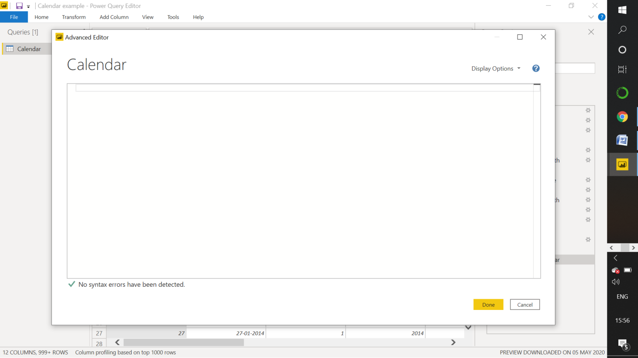

**• Prepare a document with details of the following along with their price**

**− Power BI Desktop**

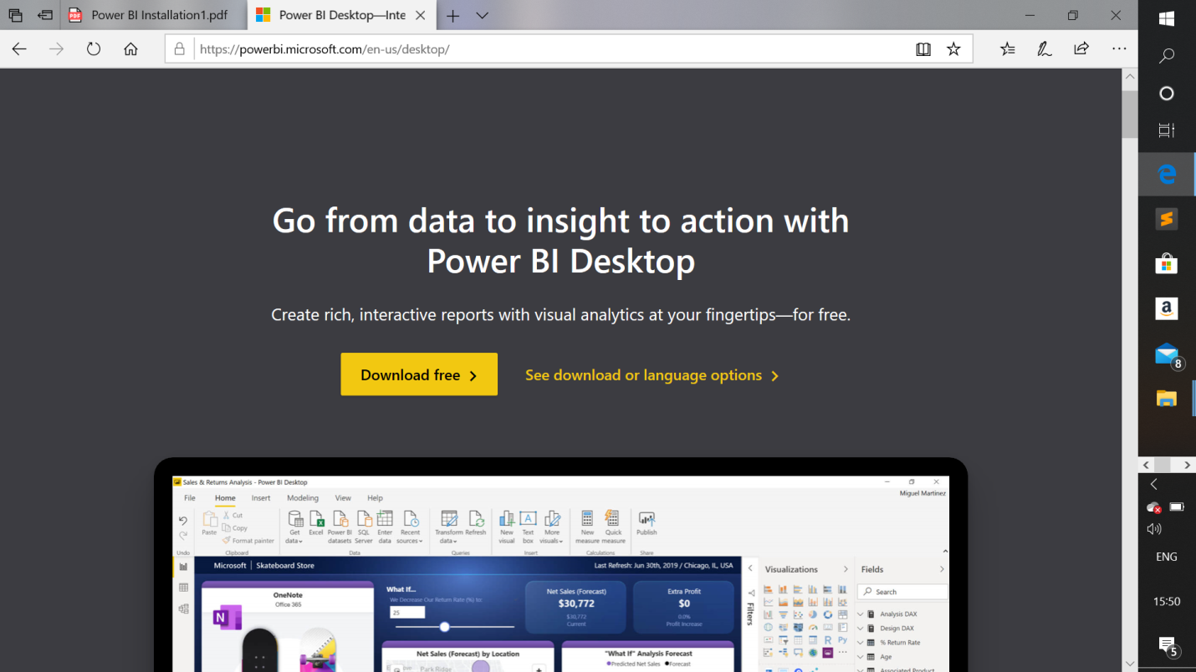

**− Power BI Pro and Power BI Premium**

